Real Time Operating Systems Design and Programming
Getting Started with KEIL µVision5 IDE and STM32L552ZEQ

Contents
1 Overview 2
2 Install the Driver for the board 2
3 Download and installation 2
3.1 INSTALLATION 3
4 Create a new project 4

Overview
Skip this part if you have already set up everything and are able to program on the board.
The lab will be based on the latest KEIL µVision5. KEIL µVision5 is a widely used IDE particularly in the embedded software field. It has full support for the STM32L552ZE development board.

Install the Driver for the Board
- Download the ST-LINK USB driver and install it: https://www.st.com/en/development-tools/st-link-v2.html
- Connect the board using a USB cable
- Go to: Computer Properties Device Manager
- Find “STM32 STLink” and right click Update Driver Software Search automatically for updated driver software

Download and Installation
First download the software from: https://www.keil.com/demo/eval/arm.htm

Installation
Install the downloaded software.
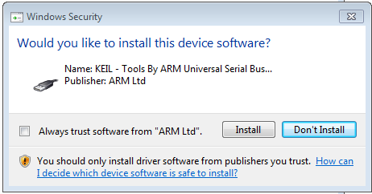
Be aware that during the installation, you may be asked if you also want to install the Serial Bus Controller. It is important to install all the drivers in order to ensure correct communication between the PC and the microcontroller device via USB connection.
Figure 1 Install the bus driver

Once finished, run the program and the Pack Installer (a new component introduced by the latest version) will start. The Pack Installer is a utility for installing, updating, and removing board-specific Software Packs. If it does not open automatically, select in the top menu: Project Manage Pack Installer
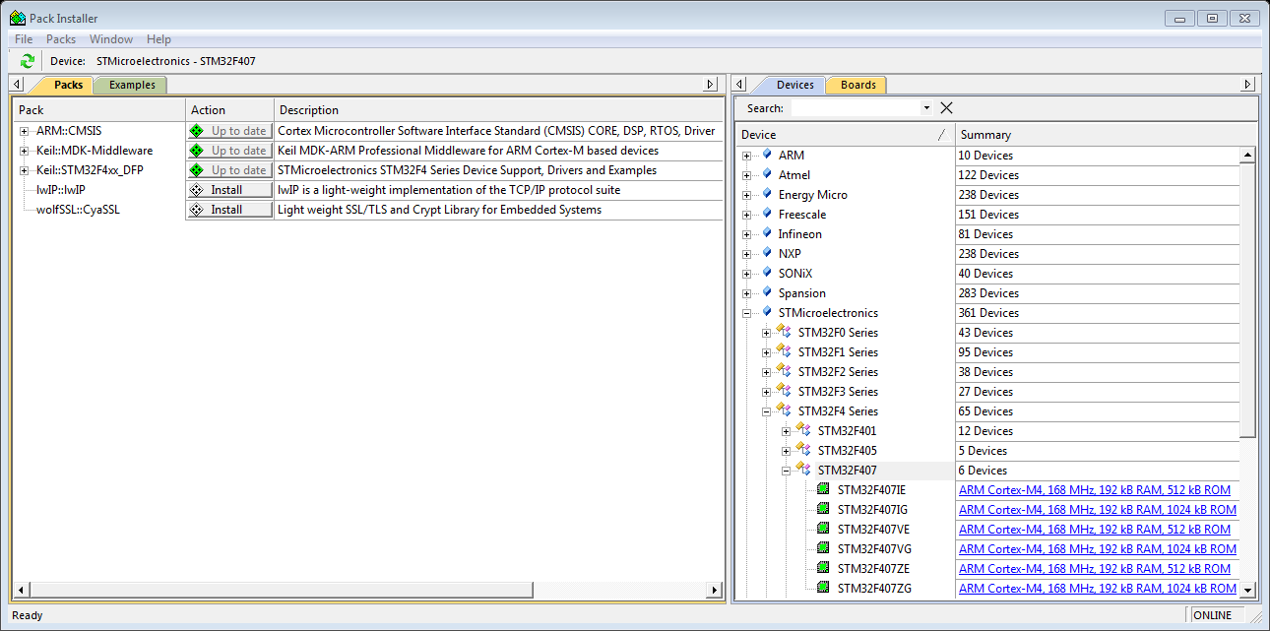
Figure 2 Pack Installer
On the right-hand side of the Pack Installer, you can search for the STM32L552ZETx family, and on the left-hand side, the program shows the available documents related to this family. You may download extra libraries, but they are not required for this course.
Finally, to be able to connect the device to the computer, you need to install an extra driver provided by STMicroelectronics, which allows for the correct recognition of the device.
Alternatively, you can download the ST-Link USB driver from the ST website at the following link: http://www.st.com/web/en/catalog/tools/FM147/SC1887/PF260218?s_searchtype=keyword#
Now, you can connect the STM32L552ZETx board to your computer using a USB type A to Mini-B cable and the device will be recognized with the name STM32 STLink.

Create a New Project
To create a new project, open KEIL µVision and select from the top menu Project New µVision Project and choose the name and location of the new project. Then you have to select your device from a list. Note that if you haven’t installed the package of your device with the Pack Installer, your device may not appear in the list. The device we are using is STM32L552ZETx.
Then you may need to configure the runtime environment as follows:
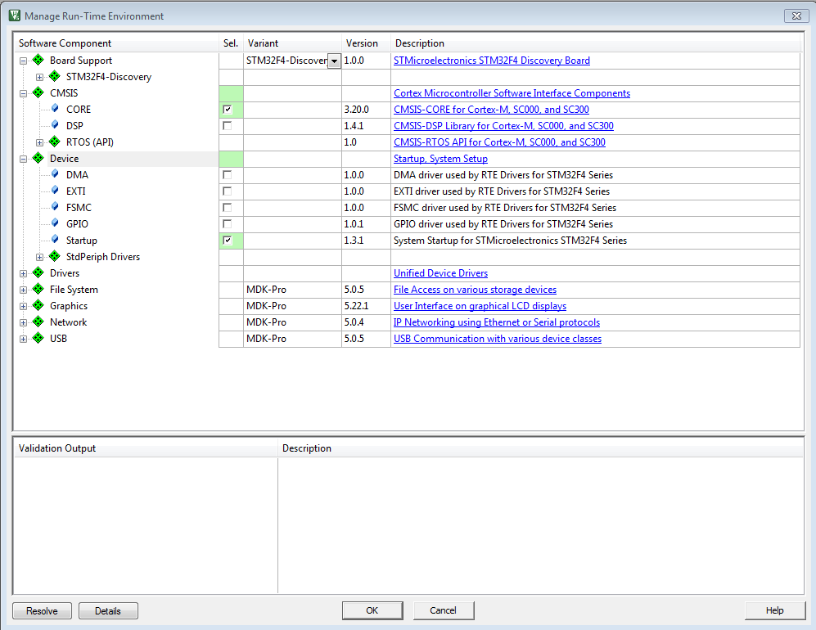
Figure 4 Run-time environment configuration

Your project file will automatically include the startup files for the board. You may also include more libraries and other files through the Manage Run-Time Environment icon.
For compatibility reasons, in some projects, you may need to manually include some of the start-up files instead of using the runtime management.
Then, click on the Options for Target icon and do the following:
You need to indicate to the program that you are using the ST-Link to communicate with the board. In the Debug tab, select ST-Link Debugger from the list (if you are using the on-board ST-Link Debugger).
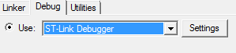
Figure 5: Debugger configuration

Then press Setup and select Port SW in the Debug Adapter area. Finally, in the Utilities tab, click the Settings button for Use Debug Driver, and add the STM32L5xx Flash (On-chip Flash) to the programming algorithm.
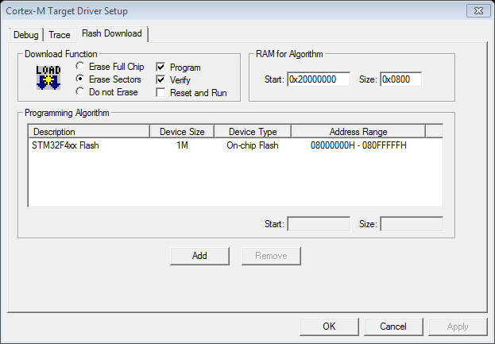
Figure 6: Debugger configuration
You can now start adding program files to the project. Save a template project so that you do not have to repeat all these steps next time.
You can also use the template project provided.

For further information visit http://www.keil.com/support/

